Garrett Haldrup
March 26th, 2025
ARTH 105-01
83 Broad Street
The Powerful Post Office

83 Broad Street is a Post Office designed by Irish man John Henry Devereux in 1896-1897¹. It was designed with a Renaissance Revival style¹. I am comparing it to the Palazzo Medici designed by Michellozzo in Florence, Italy in 1444. It is an Early Renaissance building. Both of these building employ the theme of Language by both using Classical vocab and syntax.
The Rusticated exteriors of both buildings is Classical bit of vocab used in similar ways with both having the lower levels of the building be more Rusticated and as you go up the walls get smoother and less defined. This Rustication also emphasizes the archways for both buildings. This is used in the Classical Language to emphasize strength and in a way show the weight of the structure.
Another piece of vocab that both buildings use is that of embedded columns or pilasters being used to line and emphasize the windows of the buildings. For the Palazzo Medici it uses engaged columns for its windows on the second and above floor unlike the Post Office, but on the first floor of the Palazzo it uses the same vocab of having the window flanked by pilasters that look to hold up a pediment. These ideas or words are staples of the Classical Language.
The last piece for comparison is scale. The scale is another piece of Classical Language that connects both buildings. This is because both buildings are three story buildings, but appear much taller than your average three story building. This can be seen in the Palazzo by comparing it to the building to its left in the photo which also appears to be a three story building, but the Palazzo not only feels much larger but is as well. This also applies to the Post Office which can be compared to the building on its right in the second photo in the same way as the Palazzo. For the Palazzo the scale represents power for the Classical Language, but for the Post Office it is less about power and more just using those Classical words and ideas to say the Classical Language.
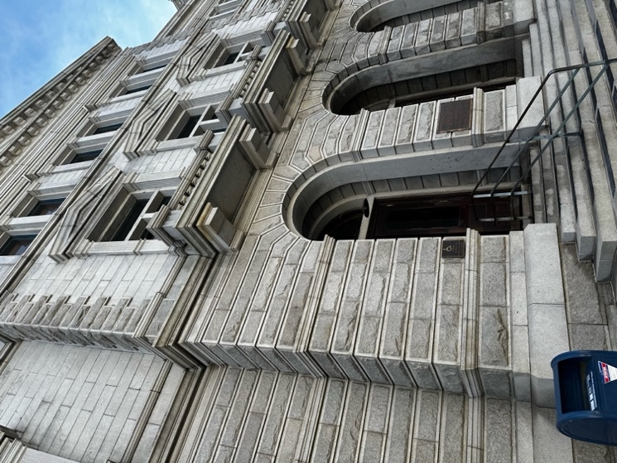
Photo 1 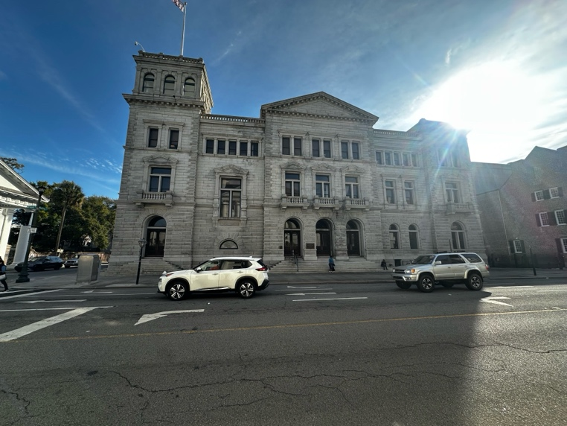
Photo 3²:
Photo 2:
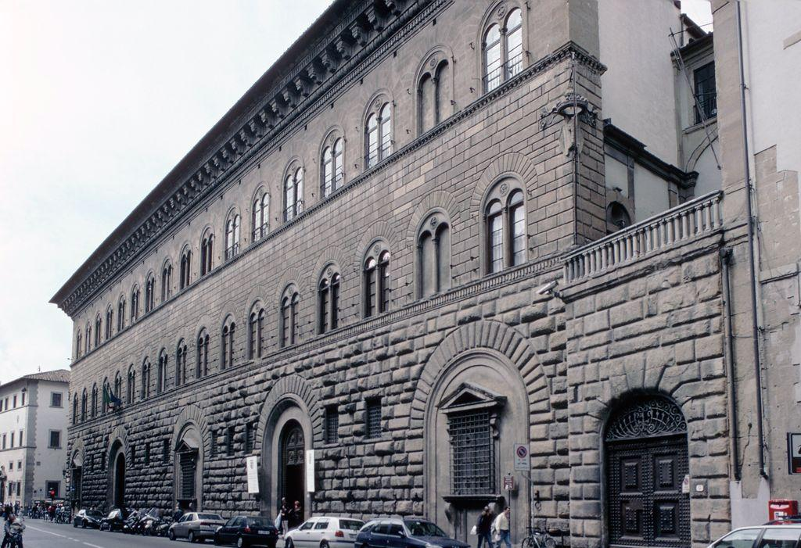
Photo 1: Of the Post Office used to demonstrate the comparison of scale for paragraph 3
Photo 2: Close up of the front of the Post Office to show the Rusticated Walls for paragraph 1 and to show the window elements for paragraph 2
Photo 3: Of the Palazzo-Medici to show the Rusticated Walls for paragraph 1, the window elements for paragraph 2 and the scale comparison for paragraph 3
Citations
¹“Archive Record.” Property File - 81-83 Broad Street (Federal Courthouse and Post Office) |
Historic Charleston Foundation, charleston.pastperfectonline.com/Archive/5341444A-14E3-46EC-B810-503627910589. Accessed 26 Mar. 2025.
² Michelozzo di Bartolomeo. Palazzo Medici-Ricardi. Begun 1444, enlarged circa 1715. JSTOR,
https://jstor.org/stable/community.14659162. Accessed 26 Mar. 2025.

