Assignment 1: Getting Started with Raspberry Pi OS Installation

Task 1: Exploring the Raspberry Pi Desktop Environment
Deliverable: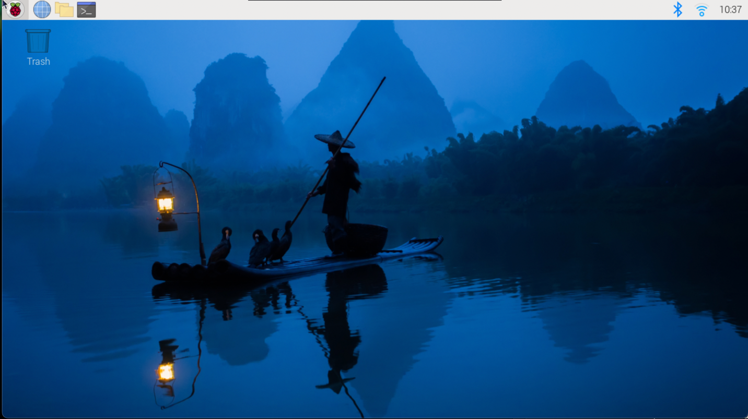
Application Menu:
Contains shortcuts to usefull programs in different catageories, and allows you to logout.
Web Browser:
A chromium based web browser that allows you to access the web
File Manager:
Look at and access your files in a gui
Terminal:
Brings up a terminal window
Bluetooth:
Allows you to make and disconnect Bluetooth connections
WiFi:
Allows you to make and disconnect Wifi connections
Calander/Clock:
Displays the current time and date
Trash:
Where you put items you want to delete or recover deleted items

Task 2: Testing Internet Connectivity
Deliverable: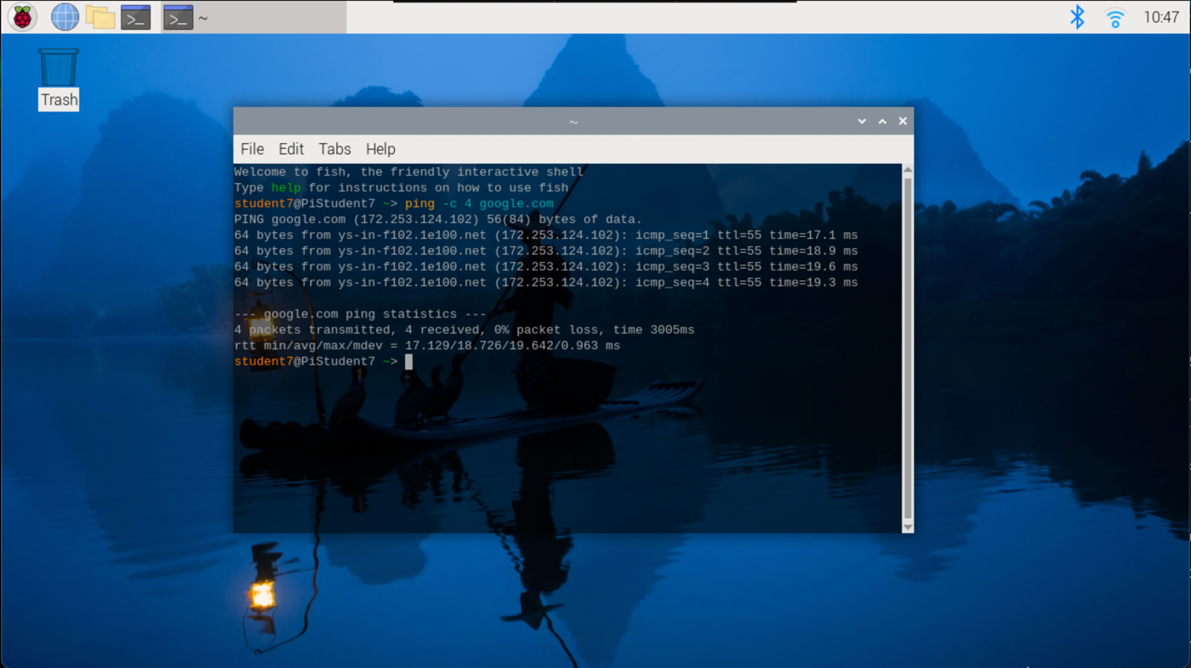

Task 3: Exploring Installed Software
Deliverable:
- A short list of three tools and their descriptions.
- Thonny
  - A python runtime and ide
- Firefox
  - A web browser for accessing the internet
- Task Manager
  - A app that lets you view current processes and their usage of system resources

Task 4: Personalized Raspberry Pi Dashboard
Deliverables:
