Activity 1:
Deliverable:
Biggest file in /var/log
Lastlog – 293k
Activity 2:
Deliverable
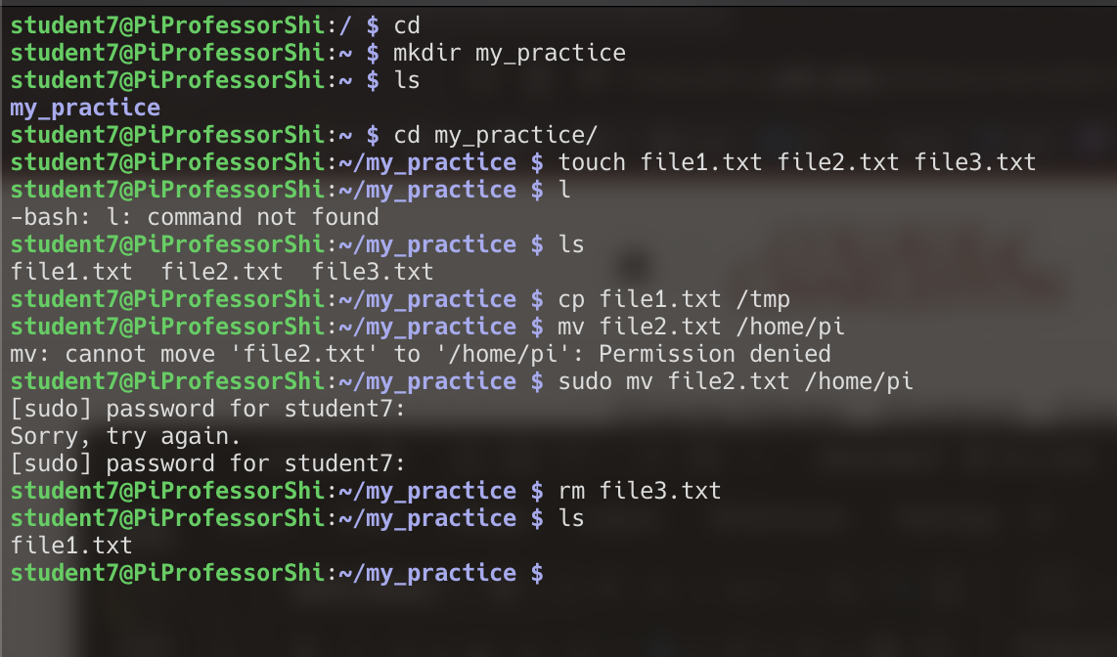

Activity 3 (4)
Deliverable
/etc/pip.conf
Root:x:0:0:root:/root:/bin/bash

Activity 4 (3)
Deliverable
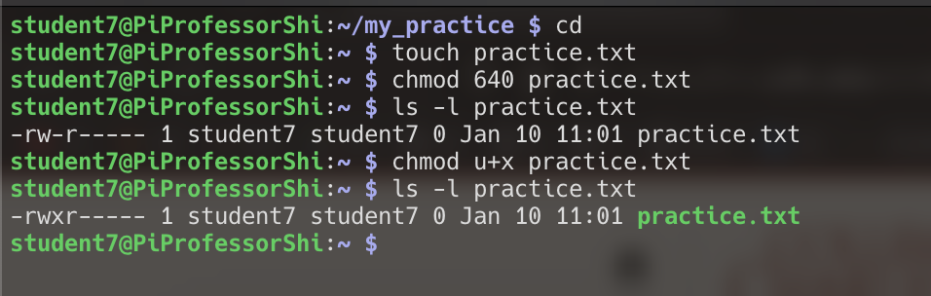

Activity 5
Deliverable
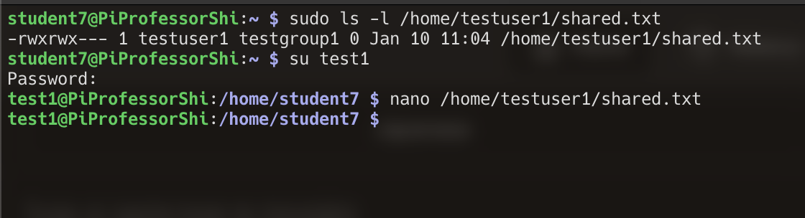

Activity 6
Deliverable
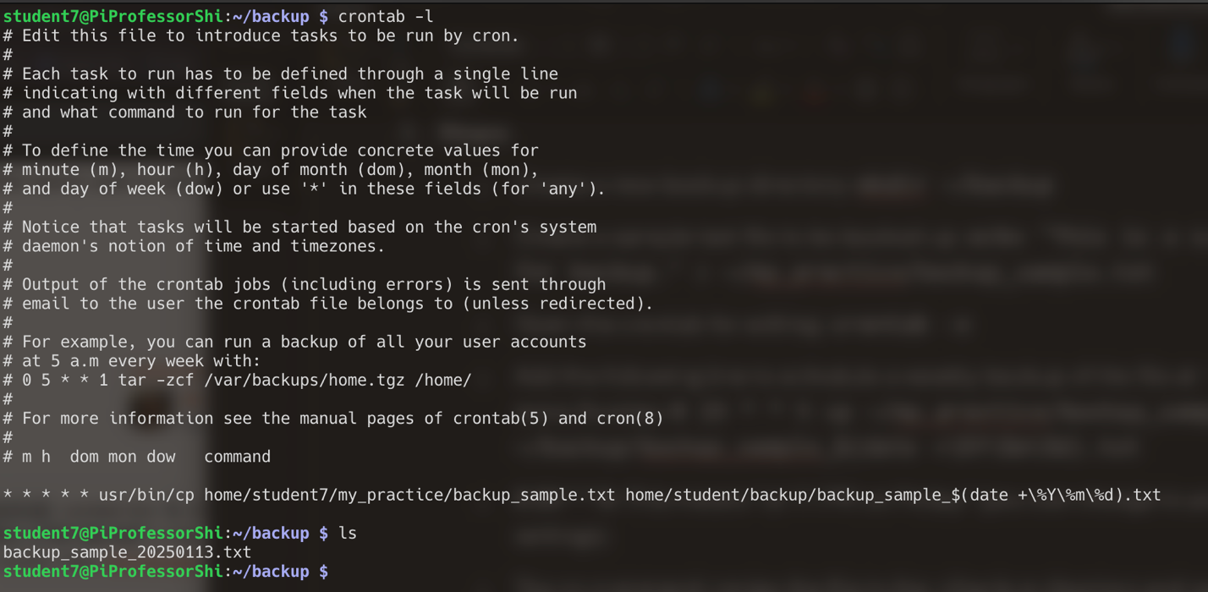

Activity 7
Deliverable
116.55 GB
93M

