Activity 1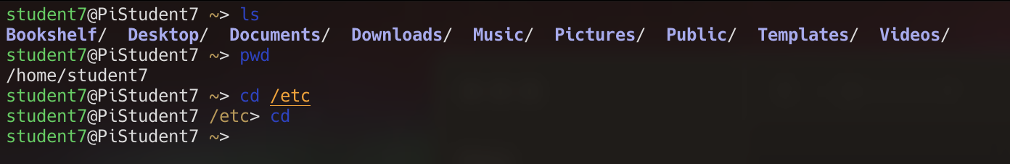
ls: lists the files and directories with in the current directory
pwd: shows the current directory
cd /etc: cd navigates to a directory of users choice
cd: shortcut that navigates to user home

Activity 2 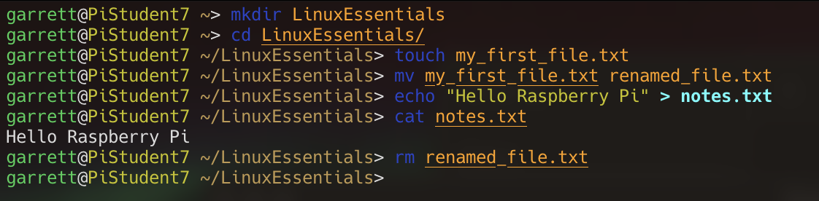
Mkdir: makes a directory in the current directory
Touch: creates a file of users choice
Mv: can move a file to a new location or rename it
Echo: puts the string as an output in the terminal, but I used a redirect to have it create a file named notes.txt with the echo
Cat: Lets you read the contents of file in the terminal
Rm: removes files
Activity 3
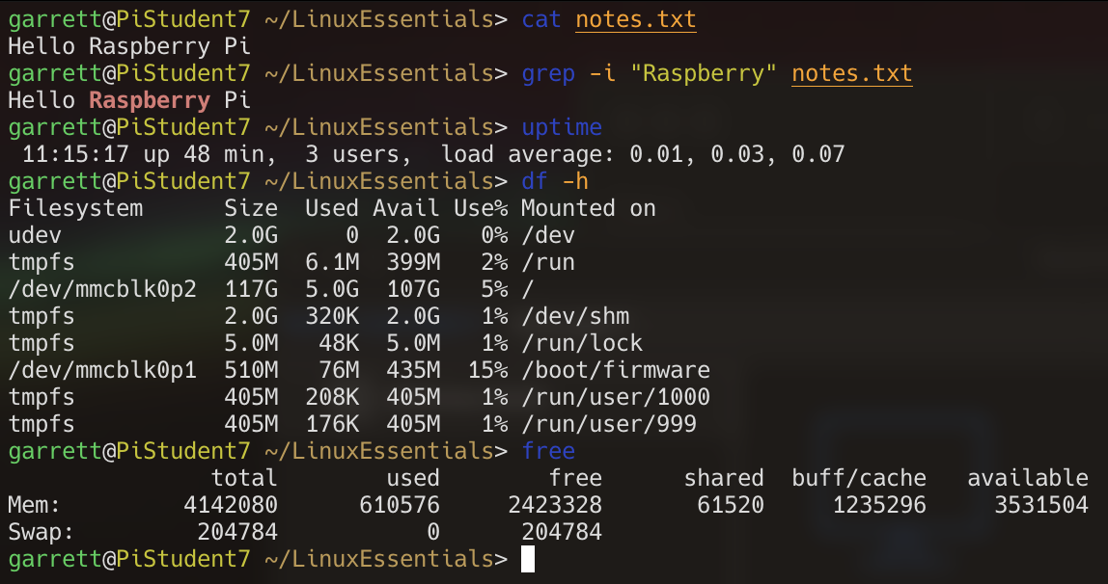
Grep: lets you search a file or list for a value
Uptime: lets you see how long and how many users are logged in
Df: lets you see the disk usage
Free: Lets you see the memory usage
Activity 4
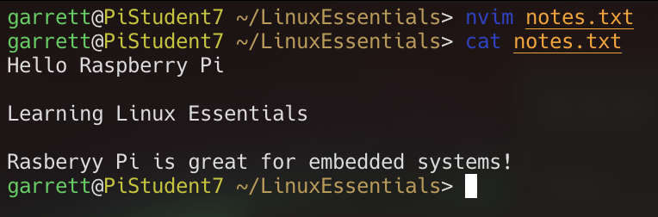
Activity 5
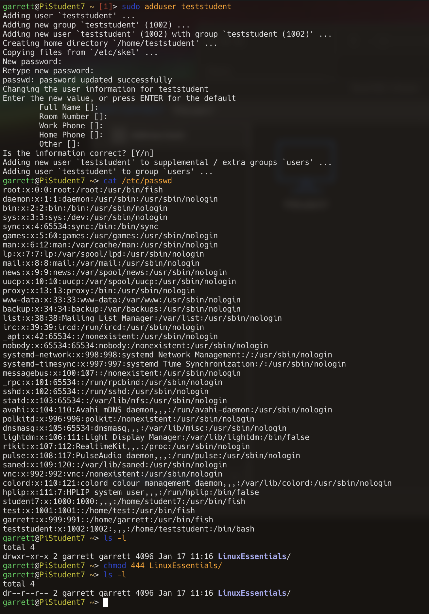
File permissions are import because they limit how other users can interreact with each other. Without it any user could access any file and modify it.

