Garrett Haldrup Assignment 4
Task 1:
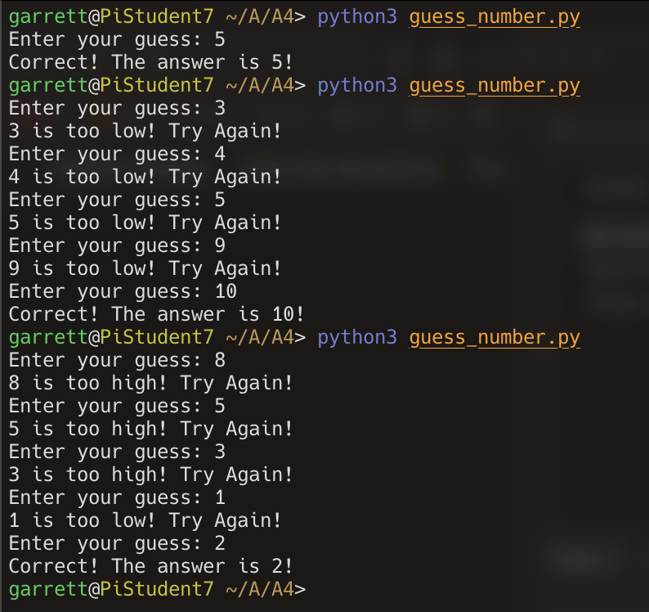
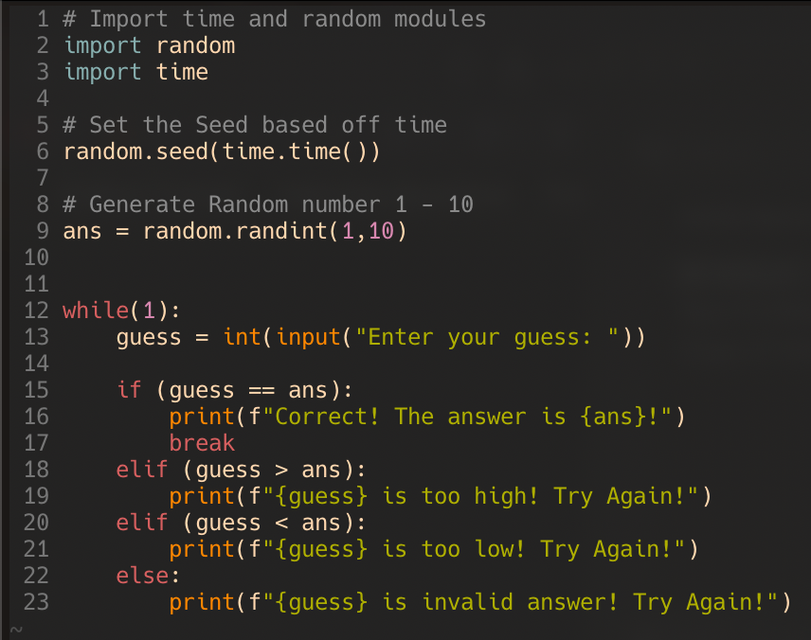
Task 2:
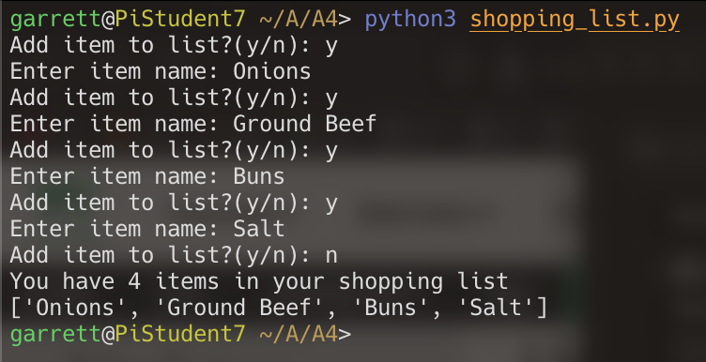
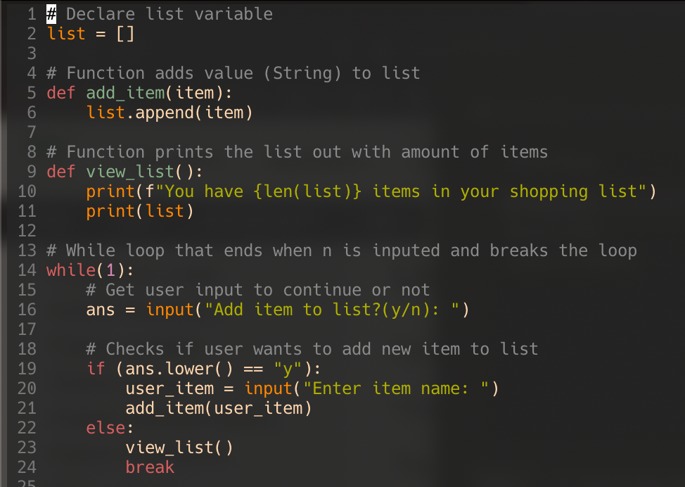
Bonus Task:
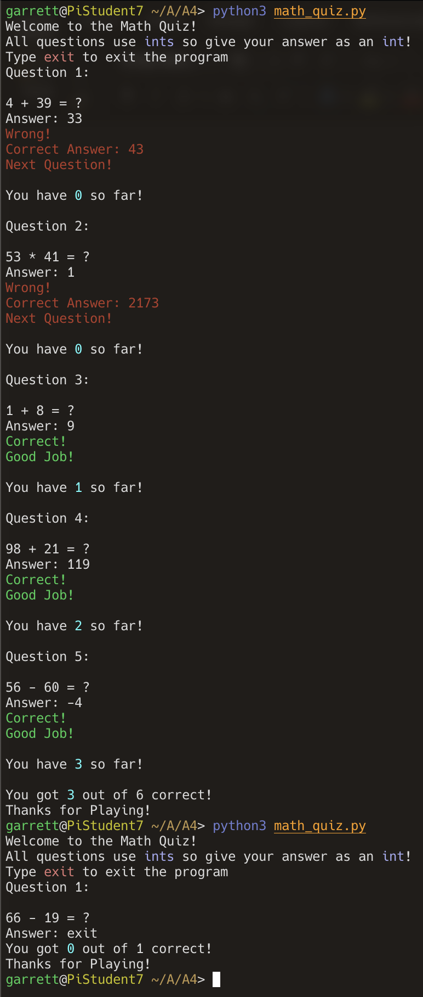
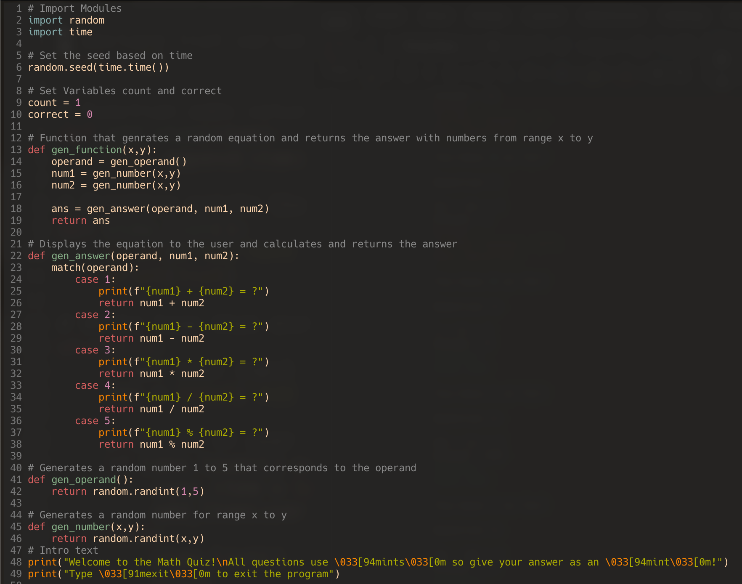
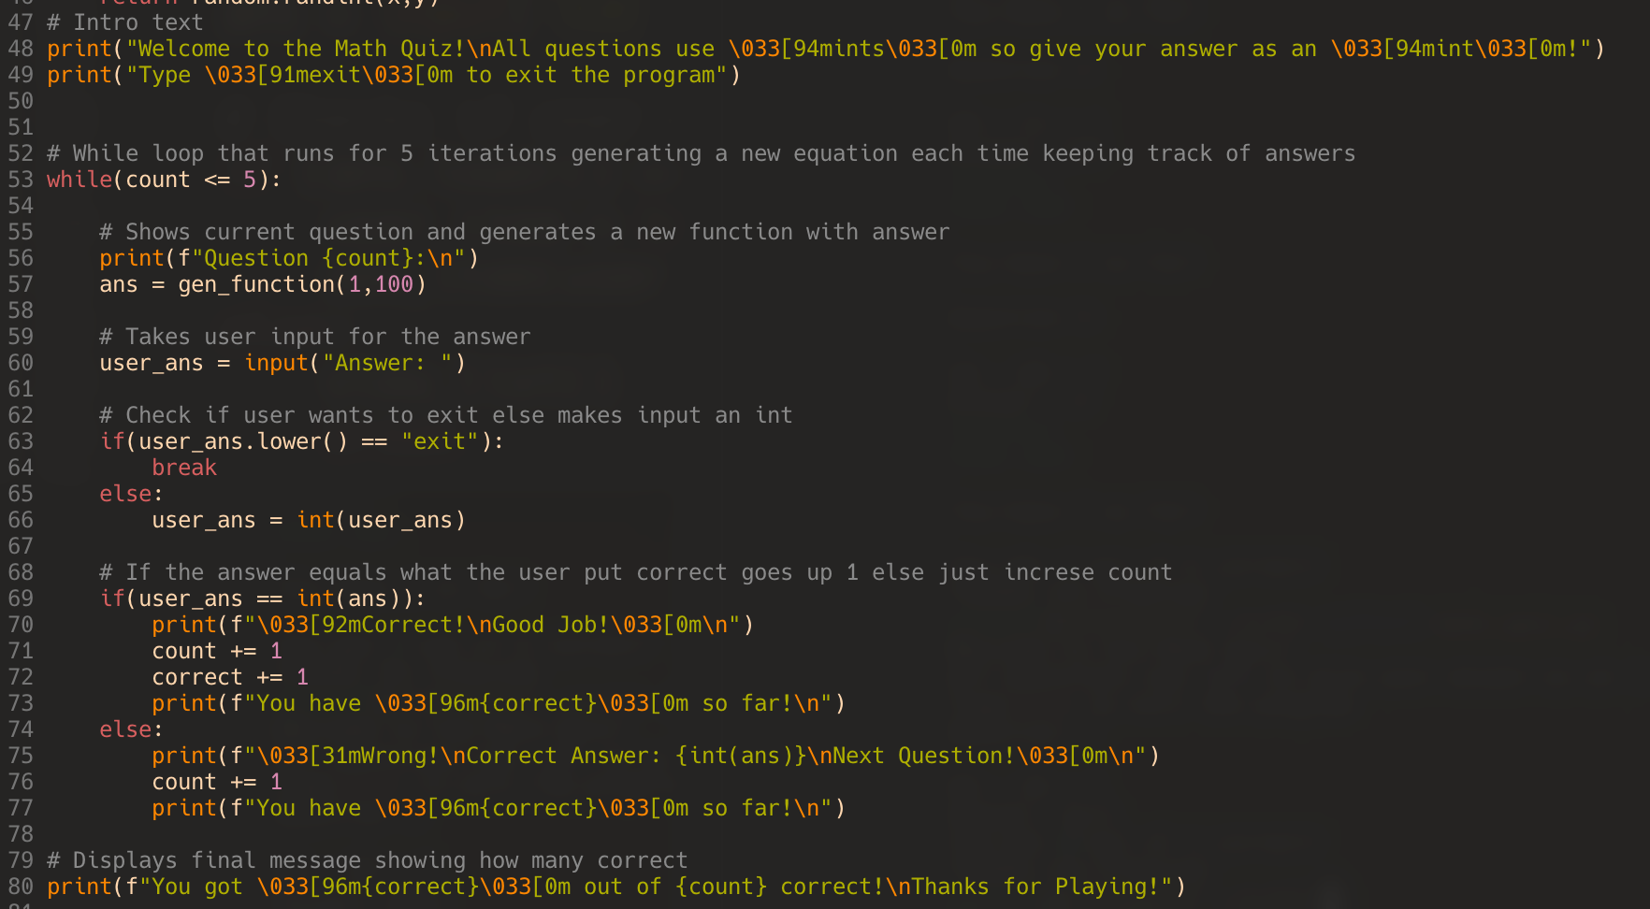

Discussion Questions
- A loop is for when you need to iterate over one set of items, while a function is used for when you need to do same exact thing multiple times
- I like the bonus task the most because it was the most complex program for this assignment, and I got to play around with changing output text color which was fun

