Activity 1:
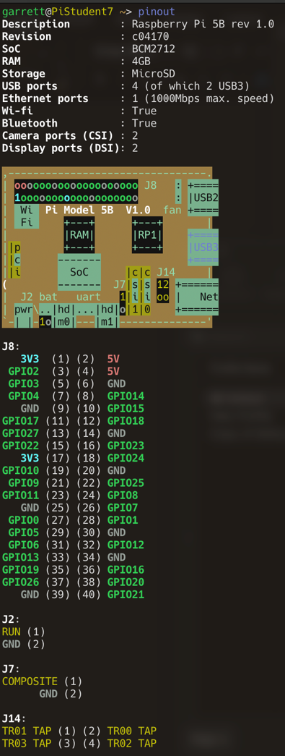
5V Power: Physical Pins 2 and 4. Supplies 5V to anything connected to it
3.3V Power: Physical Pins 1 and 17. Supplies 3.3V to anything connected to it
Ground: Physical Pins 6, 9, 14, 20, 25, 30, 34, 39. Connects the ground to the ground of your circuit and need to receive signals from pi so whole circuit is on a common ground.
GPIO18: Physical Pin 12. It is used by PCM to provide a clock signal for audio devices that use PCM. Can also function as regular Input and Output pin.
GPIO17: Physical Pin 11. A simple Input and Output pin that can be controlled by the PI.

Activity 2:
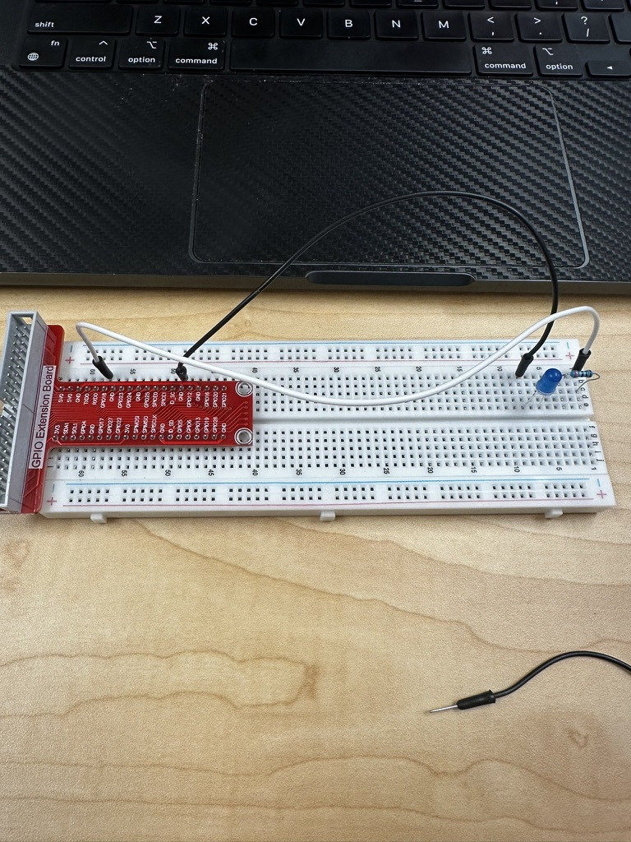
330Ω Resistor
LED: Short leg connected to ground and long one connected to GPIO18 through a 330Ω Resistor
GPIOExtenstion Board; Makes it easy to access the RPi Gpio pins on a bread board
Activity 3:
Skipped RPi.GPIO Doesn’t work with my Pi5
Activity 4:
See Attached Files

