Garrett Haldrup Assignment 6
Assignment 1:
Explain the principle of Pulse Width Modulation (PWM) and how it used to control the color of the RGB LED.
Pulse width modulation is way to control the speed and output of devices that are typically on or off. This is done by modulating the signals duty cycle percentage. The duty cycle percentage is the time that the signal is pulled high for. For example, if your frequency is 1hz and you have a duty cycle of 50% you would output maximum voltage for .5s then no voltage for .5s and repeat. Although PWM signals typically operate at much higher frequencies, so it more closely matches a dynamic voltage behavior.
Bonus Assignment:
Capped at 50% speed
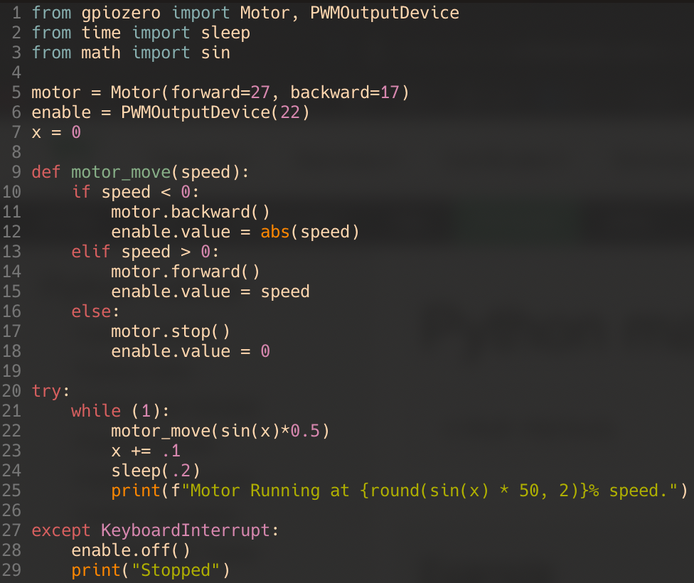
Video: see haldrup_motor_control.mp4

