Assignment 8 Garrett Haldrup
1)
See haldrup_active_buzzer.mp4
A S8050 PNP transistor is need because the signal from the Pi needs to be amplified so it is possible to hear the buzzer

2)
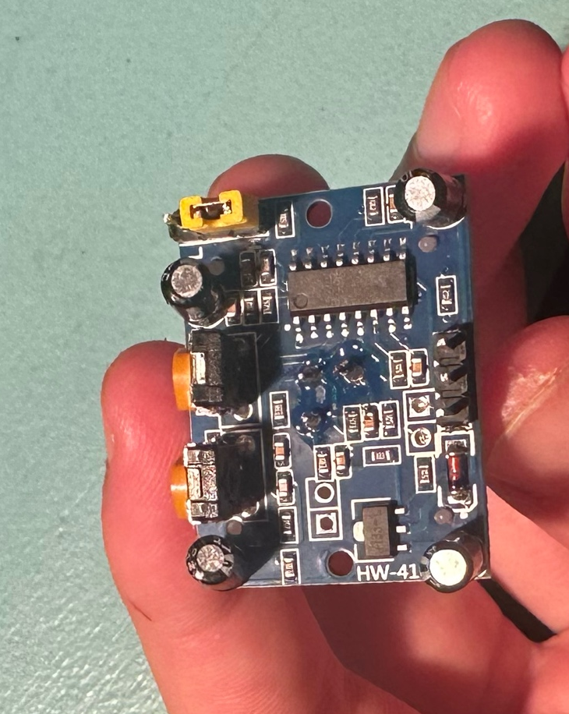
6
5
4
3
2
1
- Delay Adjustment Pot: Adjusts the delay that the pin is high after motion detected
- Distance Pot: Adjusts how sensitive the device is
- Trigger Mode Jumper: Select either H or L mode depending on desired device behaviour
- Voltage Regulator: Regulates the voltage to 3V
- PIR Chip: The main chip that controls to functions and input and output of the PIR sensor
- I/O pins: Ground, Output Pin, and VCC pins

