Garrett Haldrup
January 31st, 2025
ARTH 105-01
83 Broad Street
The Imposing Post Office from the Past

83 Broad Street is a building that houses multiple functions. One being a Untied States Postal Service center, and the other being a Postal Museum. This is large imposing building made up white stone. The Post Office contains many elements for its architecture, but three are most important. Those are scale, ornamentation, and movement.
In photos the scale of 83 Broad is not transferred well. This is because from photos it seems to be just a slightly larger three-story building, but in person there are a few elements that enhance its scale compared to people. The first one is that the entrance is elevated off the ground around 6 feet. Unlike other buildings with elevated entrances this one has no porch or level area before you enter. Instead, it just has a sequence of steps toward the doorway. Another element that enhances the buildings scale is the high doorway. The doors themselves are not particularly wide, but they are tall. They are then extended by the window that fills the archway makes the entry way feel exceptionally tall. Lastly the final element is one that is not seen till one enters the building. This is the height of the first-floor ceiling. While from the outside this looks like a three-story building it is in-fact only two. This continues the effect of the doorway making you feel small by when entering the ceiling is nearly double that of the archway.
Another important element of 83 Broad is ornamentation. This building is mostly just a rectangle, but it looks much more than that. This is because each brick is pronounced and seems very important in their function. It also uses pediments at the top of each main entrance to mark their importance. It seems to incorporate classical architecture with architecture from a caste. This can be seen by the already mentioned pediments with their entablature, and the embedded square pillars that line the windows to hold up more embedded pediments above them. The castle design comes in from the walls that jut in and out. It also seems to have towers in a way on each corner with the corner that intersects Broad and Meeting the tallest.
The final element is of 83 Broad is movement. Being on street corner there are two main entrances to the public. Even though there are more doors and stairs that lead up to them it is easy to spot which ones are meant to be entered from. This is because these entrances have a gripping surface on the steps and a metal handrail to go with it. Often though you see people resting on the stairs that do not lead to a valid entrance since the stairs get wider as they get further away from the building. Inside is quite simple. The public entrances enter into a large room for all of the P.O. boxes with a small room attached that has postal services, and them another room attached to that for the Postal Museum. This means that a user of the space will have to walk through each part of the building if they wish to get to the museum.
Overall, 83 Broad has lots of interesting elements to it, but scale, ornamentation, and movement are the most important for the building. They together describe an experience that will leave an impressing because of the scale it makes you feel and the ornamentation that calls back to classical and even medieval period with the movement that forces you to experience it all.

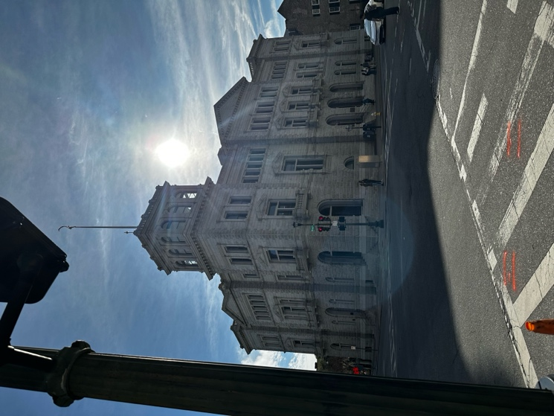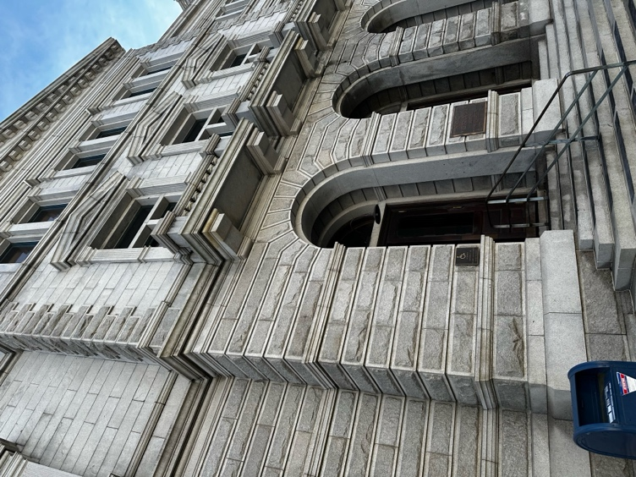
Shows a bit of the scale when up close (taken at 0.5x zoom) and the details on the bricks
The intersection of 83 Broad showing the medieval like castle tower with the pediments of the two entrances

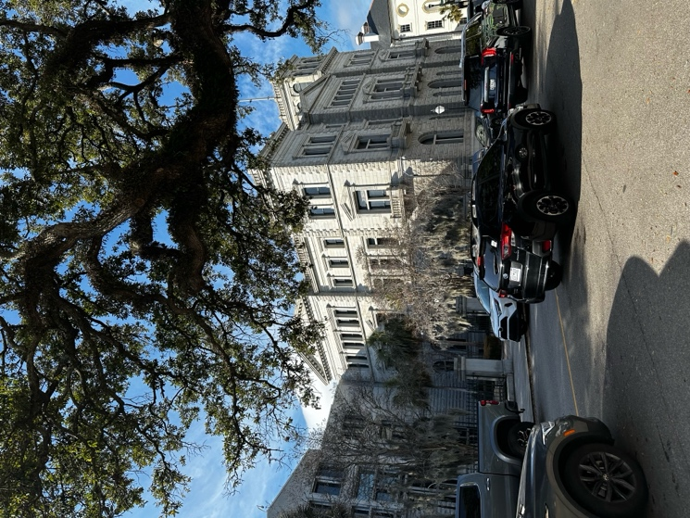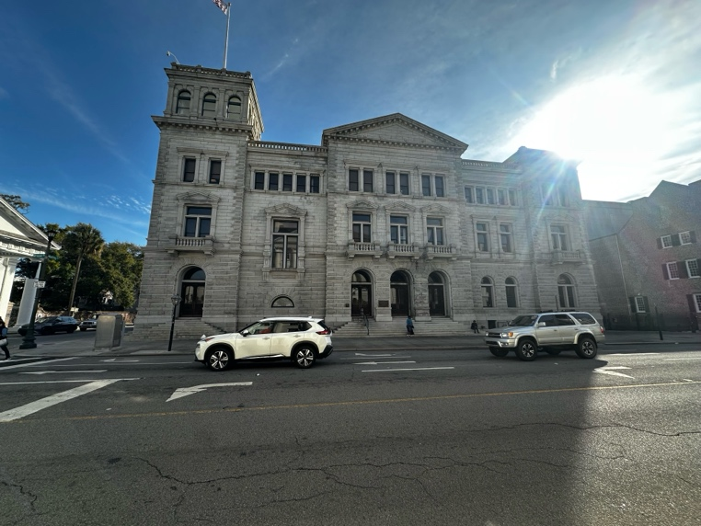
View from across Broad. You can see people resting on the steps
The rear of the building that sits up to a courtyard

