Garrett Haldrup
Activity 1:
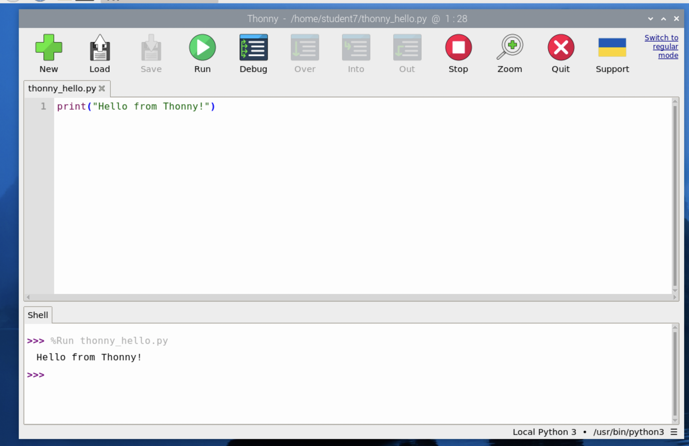
Activity 2:
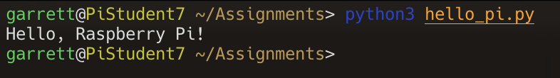
Activity 3:
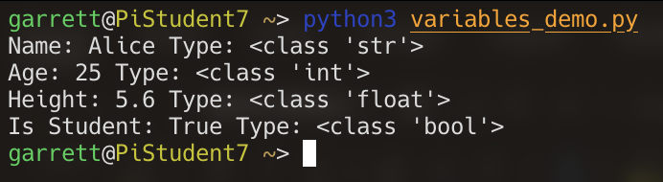
Activity 4:
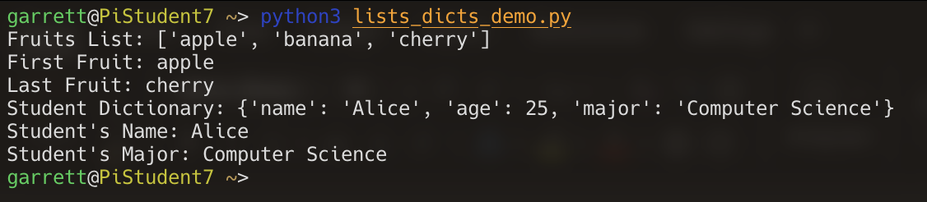
Activity 5:
