Garrett Haldrup
Task 1:
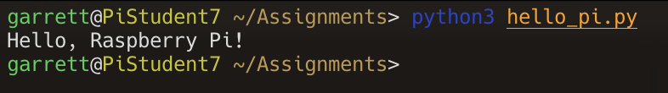
Task 2:
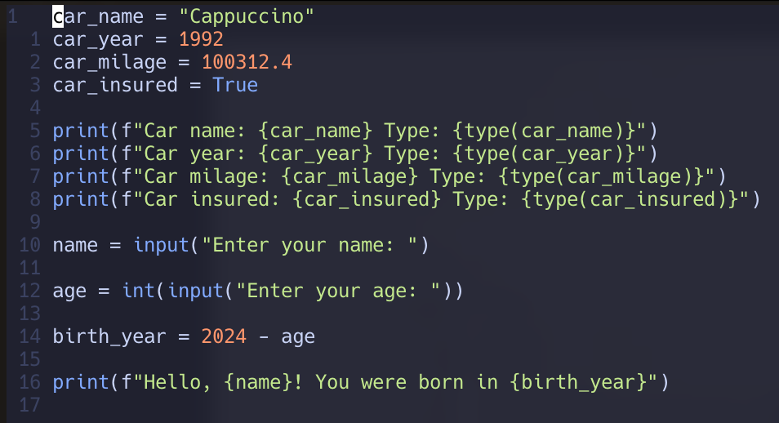
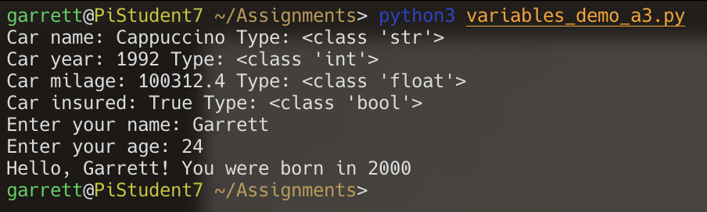

Task 3:
