Task 1:
There are many things to consider when working with GPIO. One of the most important things to consider when working with GPIO pins is the voltage being applied to the pin. GPIO pins are not made for more than 3.3V so anything more could damage the Pi. You also want to consider the current draw of anything connected to the pins. You will want a current limiting resistor connected to pins to protect the Pi. This also makes sure that if you accidently short pins as long as you have resistor in there it won’t be a dead short. You will also want to avoid static electricity as this too can damage the Pi if you are not careful.
Task 2:
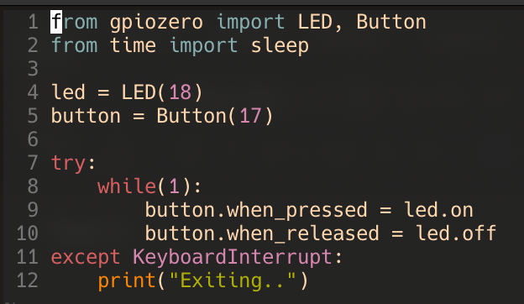
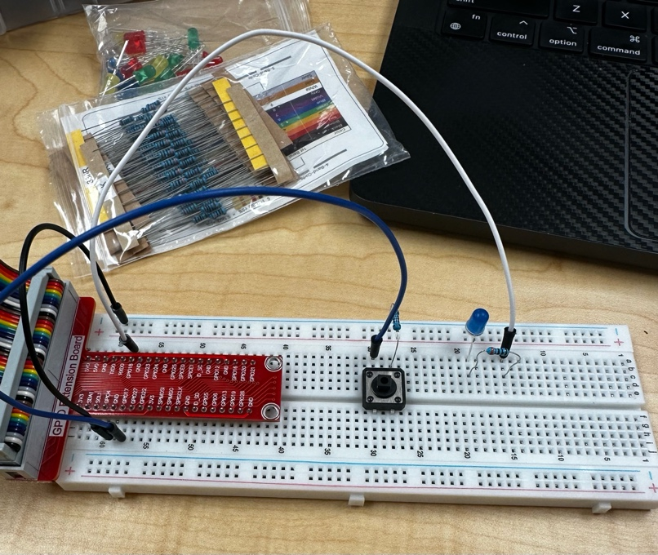

The pull-down resistor is need so that when not pressed the button is at a low state.
Task 3:
Reed Switch Module:
This is simple module that can detect when something magnetic is close to it. It is recommended that the distance between the magnet and switch is 1.5cm. This module has three pins total, one for 3.3 or 5V, one for ground, and one for data output. The module will output a high signal when there is no magnet nearby it and output low when one is close. You can also adjust the sensitivity of the sensor through the potentiometer. This can be used for many things, but one is potentially a way to tell when a door is closed by having a magnet in the door where you could embed the sensor somewhere hidden unlike a micro switch.
Speed Sensor Module:
This is another simple module that while it says it’s a speed sensor it does not actually output the speed of an object. It has four pins total, but only three are used in the circuit, one for 3.3V, one for ground, and on for data output. This module works by having two towers with one having a emitter and anther a receiver. There is a small hole facing each tower so the receiver can see the emitter. When something blocks the emitters path to the receiver the module will output low while otherwise outputting high. While this module does not output the speed of something directly it can be used to calculate the speed of something. For example, you could have a disc with a slot cut out of it and then put the sensor on the perimeter of the disc. Since you know the circumference of the disc you could measure how long between pulses of high output to measure the speed the disc is spinning.
Discussion Questions:
- The purpose of using resistors for LEDs is to limit the current of the circuit so that LED does not burn out and so you also don’t damage the RPi GPIO pins. It is important to use resistors for buttons because it ties the button to a low signal when unpressed, and it also helps with limiting current of the circuit if you wire anything incorrectly.

